**SC1**

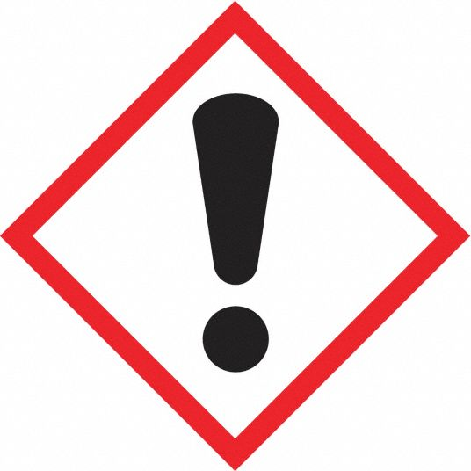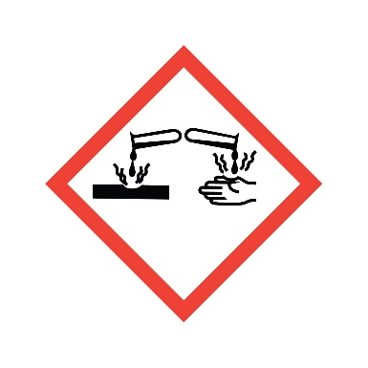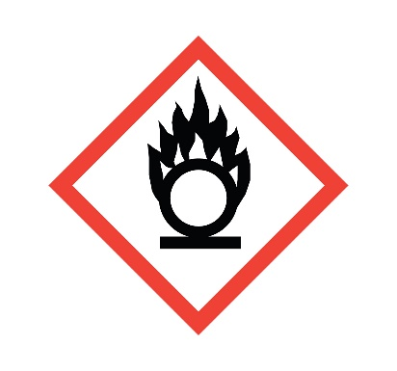

**Danger**

Causes skin irritation and eye damage.

**Composition**

**3% H2O2 + NH4OH + DI Water**